 | MINISTERUL EDUCATIEI NATIONALE  LICEUL TEHNOLOGIC „DACIA” - PITEŞTI | 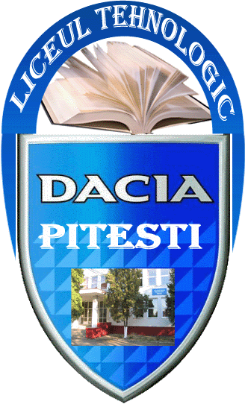
Str. Henri Coanda, nr. 4, Piteşti, Jud. Argeş
Tel.: 0248/212334; Fax : 0248/212334 ; E-mail: dacialiceutehnologic@yahoo.ro
Nr. ...........................

Analysis report of students' reflexive journals
on Learning/Teaching/Training from Turkey

The first Learning / Teaching / Training activity took place in Turkey, Burdur, at the Vocational High School from Burdur, from 19.11 to 23.11.2018, with 6 pupils from the partners from Lithuania, Romania and Turkey and 5 pupils from Italy. The assessment of the LTT's results in Turkey was made by:
- Mobility Activity Report
- Analysis report of students' reflexive journals
- feedback queries, initial and summative
- questionnaires to measure the achievement of the project objectives.
Din analiza jurnalelor reflexive completate de catre elevii participanti la mobilitatea din Turcia s-au constat urmatoarele raspunsuri:

La punctul ”Concepts / Abilities”:
- Concepte de baza programare SCRATCH
- Comenzi de baza pentru programarea unui robot
- Concepte de baza in programare vizuala, in programare textuala
- Sisteme de programare ARDUINO, MBlock
- Comunicare in limba engleza
- Abilitatea de a lucre in echipe mixte cu elevi din tarile partenere in proiect

La punctul ”Actions/ Specialized learning techniques”:
- Invatare prin descoperire, invatare prin proiecte, lucrul in echipa
- Comenzi de baza pentru programarea unui robot
- Comenzi de baza pentru programarea unui robot
- Programe ARDUINO, MBlock
- Lucrul in echipa
- Lucrul pe baza de proiecte
- Team building

La punctul ”What I learned?”
- Creare de povesti animate
- Programare notiuni de baza
- Programare notiuni de baza
- Familiarizarea cu sistemele de programare ARDUINO, MBlock
- Dezvoltarea abilitatilor de comunicare si de interrelationare
- Dezvoltarea abilitatilor de comunicare si de interrelationare

La punctul ”How did I learn?”

- Realizarea unei animatii in SCRATCH printr-un traseu desenat sau creat de elevi, cu folosirea unui text
- Expunere
- Simulare
- Expunere
- Simulare
- Expunere
- Simulare
- Lucrul prin proiecte, lucrul in echipa,
- Activitati individuale
- Schimb intercultural
- Orientare
- Lucrul prin proiecte, lucrul in echipa,

La punctul ” How did I feel?”
- Entuziasmat
- Interesat
- Motivat
- Informat
- Entuziasmat
- Interesat
- Motivat
- Informat
- Entuziasmat
- Interesat
- Motivat
- Informat
- Entuziasmat
- Interesat
- Motivat
- Informat
- Entuziasmat
- Increzator
- Gandire pozitiva
- Incredere in sine
- Atitudine pozitiva fata de viata, sarcini de lucru
- Capacitatea de a lua decizii
- Independenta
- Stima de sine ridicata
- Incredere in fortele proprii
- Initiativa

In conclusion, all the activities carried out in Turkey's mobility have been carried out according to the agenda drawn up by the Turkish partner, all the objectives set in the approved project have been achieved and tangible and intangible results have been obtained.

Written by the project coordinator,

Prof. Iuliana Ionita

